# Exploring the Relationship Between PPG Data and HRV

## Abstract

Previously, we introduced Photoplethysmography (PPG) and Heart Rate Variability (HRV) as key metrics for health monitoring, emphasizing their use in wearable devices. We discussed how PPG captures heart rate and how HRV provides insights into the autonomic nervous system. In this follow-up, we will dive deeper into how PPG signals can be used to derive HRV measurements, assess the accuracy and reliability of PPG-derived HRV compared to ECG, and review foundational research in this area.

## 1. Recap: Introduction to PPG and HRV

In the previous document, we covered the following key points:

* **PPG**: An optical technique that measures blood volume changes in tissue, primarily used in wearables to monitor heart rate.
* **HRV**: Defined as the variation in time between heartbeats, serving as a marker for stress, recovery, and overall cardiovascular health.
* **Applications in Wearables**: Discussed how leading brands like WHOOP and Oura use PPG and HRV to track stress levels, sleep quality, and recovery.

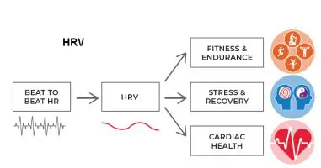

*Image 1: PPG and HRV's Role in Health Monitoring*

## 

## 2. The Relationship Between PPG and HRV

While the previous document introduced the basic concepts, this section will further explore the relationship between PPG and HRV and how PPG signals are used to measure HRV.

## 2.1 How PPG Signals are Used to Derive HRV

PPG signals can be processed to estimate the intervals between heartbeats, known as RR intervals. These intervals, when analyzed over time, provide insights into HRV. The process typically involves filtering the PPG signal to remove noise and extracting the peaks of the signal that correspond to heartbeats. The time between consecutive peaks forms the RR intervals, which are then used to calculate HRV.

#### 

*Image 2: A visual representation of how PPG signals are processed to derive HRV*

**Key Point:**PPG offers a practical, non-invasive way to monitor HRV continuously, making it ideal for wearables and long-term health tracking. However, challenges arise due to noise and motion artifacts, which can affect signal quality.

## 

## 2.2 PPG Processing Pipeline

The PPG processing pipeline for HRV measurement begins with the capture of raw signals using wearable sensors, which track blood volume changes in tissue. These signals often contain noise from motion and environmental factors, which is addressed through a band-pass filter. This filtering process removes high-frequency noise and prepares the signal for analysis.

Next, the filtered signal is segmented and evaluated for quality. If the signal meets the required threshold, it proceeds for HRV extraction. If not, motion artifact detection and reduction methods are applied to improve the signal’s integrity.

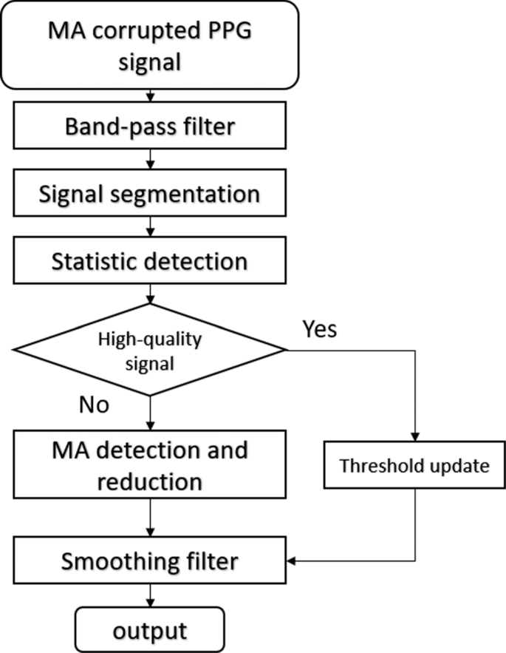

*Image 3: Data processing pipeline for PPG*

After noise removal, the signal is smoothed using additional filters to facilitate accurate detection of heartbeats. Peaks in the signal, corresponding to heartbeats, are detected, and the time between consecutive peaks (RR intervals) is calculated.

Finally, HRV is derived from the variability between RR intervals, with higher variability indicating better autonomic regulation, while lower variability may signal stress or fatigue.

## 3. PPG Data and Noise Handling

## **3.1** **Common Noises in PPG Data**

PPG signals are often corrupted by various types of noise, which can impact the accuracy of HRV measurements. These noises need to be filtered out during the preprocessing stage. Below are the common types of noise that affect PPG signals:

* Movement Artifacts: Caused by physical motion, movement artifacts significantly distort the PPG signal. As shown in the image, movement can create abrupt and erratic variations in the signal, making it difficult to identify accurate peaks for heartbeat detection.
* Electromagnetic Noise: External electronic devices or electromagnetic fields can introduce high-frequency noise into the PPG signal. This type of interference typically produces a more uniform, high-frequency distortion, as depicted in the image, affecting the signal's clarity.

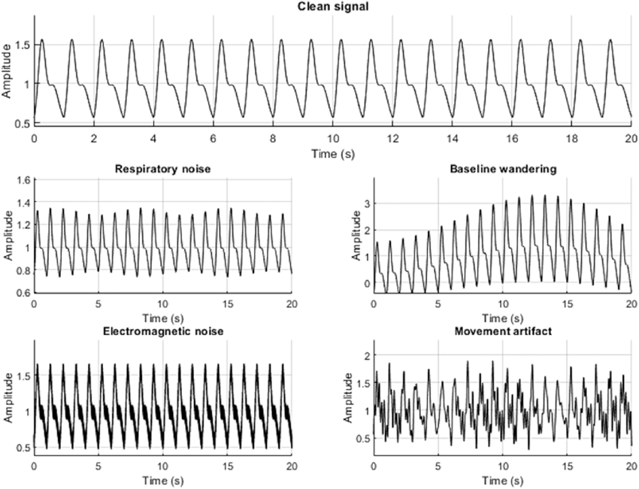

*Image 4: Types of noises in PPG data*

* Baseline Wandering: Baseline wandering occurs when the signal drifts up or down over time due to changes in sensor position or tissue properties. This creates a slow, large-scale variation in the signal, which is unrelated to heart activity but can complicate peak detection.
* Respiratory Noise: Breathing can influence blood flow, causing fluctuations in the PPG signal that mimic heart rate variations. These respiratory-induced changes create lower frequency modulations in the signal, as shown in the image, and may overlap with the true heartbeat signal.

## 3.2 PPG Signal Filtering and Noise Reduction

Effective filtering of PPG signals is crucial for accurate HRV measurement, as it removes noise and allows for the precise detection of heartbeats. The following are key steps involved in filtering and noise reduction, to begin with noise handling:

* Signal Preprocessing: The first step is applying low-pass filters to remove high-frequency noise. This type of noise, caused by electronic interference or minor physiological factors, can distort the PPG signal, making it difficult to detect meaningful features.
* Artifact Removal: After preprocessing, adaptive filtering is applied to handle motion artifacts. Movement during PPG signal capture creates significant disruptions in the waveform. Adaptive filters dynamically adjust to these changes, minimizing the impact of motion on the signal and improving its quality.
* Peak Detection: Once the signal has been filtered and cleaned, smoothing techniques are used to ensure accurate identification of heartbeats. These techniques refine the signal to make peaks more distinct, facilitating accurate RR interval calculation and HRV derivation.

Below is an example of a PPG signal before and after filtering, showing the progressive improvement in signal quality across different stages of the filtering process.

(a - Original unfiltered signal showing significant noise; b Low-pass filtered signal with reduced high-frequency noise but visible motion artifacts; c Motion artifact detection and reduction applied, improving signal clarity; d Final smoothed signal with noise and artifacts removed, ready for peak detection. )

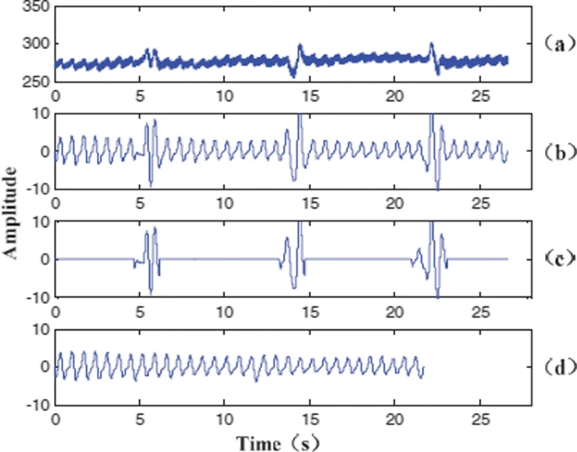

*Image 5: Removing motion artifacts*

## 

## 4 Accuracy and Reliability of PPG-Derived HRV

PPG-derived HRV is convenient for continuous monitoring, but how does it compare to the gold standard i.e. ECG?

## 4.1 ECG vs. PPG for HRV Measurements

* **ECG**: Electrocardiograms (ECG) directly measure the electrical activity of the heart and are considered the most accurate method for HRV measurement.
* **PPG**: PPG indirectly measures heart rate by detecting blood volume changes, which makes it less accurate in certain conditions, particularly during high physical activity or in the presence of motion artifacts.

## 4.2 Studies on PPG vs. ECG Accuracy

PPG-derived HRV has been widely compared to the gold-standard ECG. While PPG is generally reliable during rest and low-motion activities, its accuracy decreases during high-motion scenarios due to the introduction of noise and motion artifacts. Although PPG can serve as a viable alternative to ECG for long-term monitoring, it is important to account for the limitations caused by motion and environmental factors.

Wearables like WHOOP and Oura are continuously improving the accuracy of PPG-derived HRV by developing sophisticated algorithms to filter out motion artifacts and optimize signal quality. However, current limitations persist, as motion and external environmental factors still affect the precision of PPG-derived HRV in certain conditions.

#### 

*Image 6: Differences in HRV readings between ECG and PPG*

**Key Point:**Despite its limitations, PPG-based HRV is widely accepted in wearables for long-term tracking and general health insights. Wearable companies are continuously improving algorithms to filter out noise and motion artifacts.

## 5. Research Supporting PPG-Derived HRV Analysis

Recent research in Heart Rate Variability (HRV) has shifted from simply measuring daily values to analyzing how these values change over time, offering a more accurate reflection of an individual's health and stress levels. PPG-derived HRV plays a critical role in this, enabling continuous, non-invasive monitoring through wearables like WHOOP and Oura. By collecting HRV data over extended periods, we gain insights into how the body responds to stressors, recovers from exertion, and adapts to environmental changes.

## 5.1 Relevance of PPG in Long-Term HRV Monitoring

A key takeaway from HRV research is the recognition of its day-to-day variability, as seen in the attached chart from HRV4Training. The chart illustrates how events like food poisoning, a marathon, and a location change (heat exposure) cause noticeable drops in HRV, signaling increased physiological stress. These fluctuations are natural responses to physical activity, illness, or environmental factors.

The light blue band represents the individual's normal HRV range, a crucial tool for distinguishing between trivial daily changes and significant deviations. This moves the analysis away from "higher is better" to a more nuanced approach, where stability within the normal range is ideal. Significant drops, like those after sickness or intense activity, suggest the body needs recovery, while a return to normal indicates adaptation or healing.

The ability to derive HRV from PPG makes this kind of continuous, real-time monitoring possible, especially outside clinical settings. PPG sensors embedded in wearables capture heart rate data non-invasively, and by analyzing RR intervals (the time between heartbeats), HRV can be tracked over time. This enables individuals to understand how their bodies respond to stressors like travel, illness, and heavy exercise, as reflected in the chart.

#### 

*Image 7: HRV changes due to stressors relative to the normal range*

## 5.2 Key Takeaways

Personalized Analysis: The research emphasizes that HRV analysis must be personalized. Comparing HRV to others is not meaningful since individual baselines differ due to genetics, lifestyle, and health conditions.

Focus on Trends: Instead of analyzing isolated daily values, trends over time provide a clearer picture of overall health. Long-term stability within the normal range suggests resilience, while deviations reflect the body’s response to stressors or the need for recovery.

Identifying Acute Stressors: Events such as intense exercise (e.g., marathons), sickness, or environmental changes (heat exposure) result in short-term reductions in HRV, as seen in the graph. Tracking these changes allows for better management of recovery periods and workload adjustments.

Wearables & PPG: Continuous HRV monitoring through wearables using PPG technology is crucial for non-invasive, long-term health tracking. Tools like WHOOP and HRV4Training allow users to interpret how their body responds to daily challenges, guiding both health and performance optimization.

## 

## 6. Conclusion

PPG-derived HRV analysis offers a powerful tool for non-invasive, continuous monitoring of individual health and stress responses. From understanding the impact of daily fluctuations to identifying significant deviations caused by stressors like illness, exercise, or environmental changes, HRV provides critical insights into the body's recovery and adaptation. While advances in wearable technology have enhanced the accuracy of PPG-derived HRV, understanding long-term trends and staying within one’s normal range remains key to effective health monitoring and optimization.

## 

## References

1. Charlton, P.H., Pilt, K., & Kyriacou, P.A. (2022). Establishing best practices in photoplethysmography signal acquisition and processing. *Physiological Measurement*, 43(5), 050301. https://doi.org/10.1088/1361-6579/ac6cc4. PMID: 35508148; PMCID: PMC9136485.
2. Mejía-Mejía, E., & Kyriacou, P.A. (2022). Effects of noise and filtering strategies on the extraction of pulse rate variability from photoplethysmograms. *Journal of Biomedical Engineering*.
3. Pollreisz, D., & TaheriNejad, N. (2022). Detection and removal of motion artifacts in PPG signals. *Mobile Networks and Applications*, 27, 728–738.<https://doi.org/10.1007/s11036-019-01323-6>.
4. Altini, M. (2020, February 6). The Ultimate Guide to Heart Rate Variability (HRV): Part 1 - Measurement setup, best practices, and metrics. HRV4Training. Retrieved from<https://www.hrv4training.com/publications.html>.
5. HRV4Training. (n.d.). *Publications*. Retrieved from<https://www.hrv4training.com/publications.html>.